**Functional Document**

|  |  |
| --- | --- |
| **Application** | NGERP – Centra |
| **Service Bundle** | Inventory Management |
| **Service Request** | Internal Move Confirmation |

**Description:**

In **Compiere (NGERP - Centra)**, **Internal Move Confirmation** screen, allowing users to view in-progress documents.

**Workflow Process:**

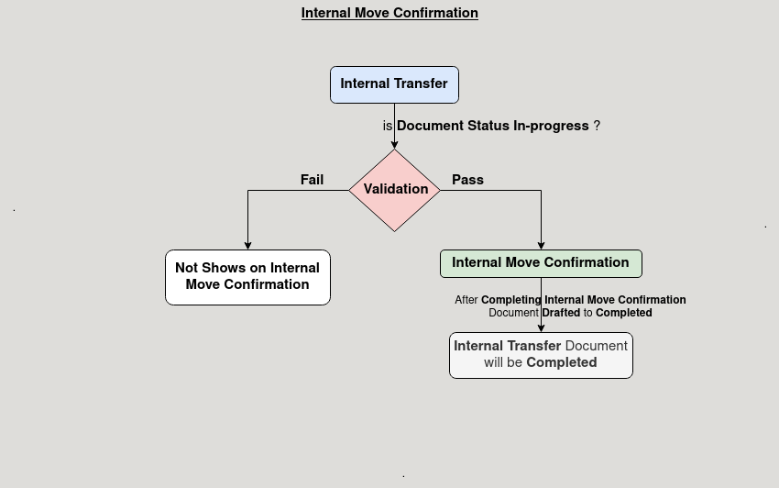

**Business Rules:**

* It is visible in both **HQ** and **ROW.**
* Only in-progress documents should be visible in the Internal Move Confirmation screen.
* It is used completing internal movement documents, but not allow voiding of internal movement documents from the confirmation screen.
* It prevent any changes to the document once it has been marked as completed in the confirmation process.